Nivabupa Health Insurance Ltd.

Infinity API
Integration Rule


Table of Contents
I. Authentication API 3
II. Member Push 4
III. Download COI 5

Authentication API

URL https://instainfinity.nivabupa.com/mobikwik/api/authentication/login
Request Type “POST”

Request Body
{"UserName": "mobikwik","Password": "mobikwik@2021"}

Response
{
"Code": "200",
"Message": "Token generated successfully",
"Status": "success",
"Data": "142d9986-50ff-4391-b3b5-d0eb230b7821"
}

Sample Screen
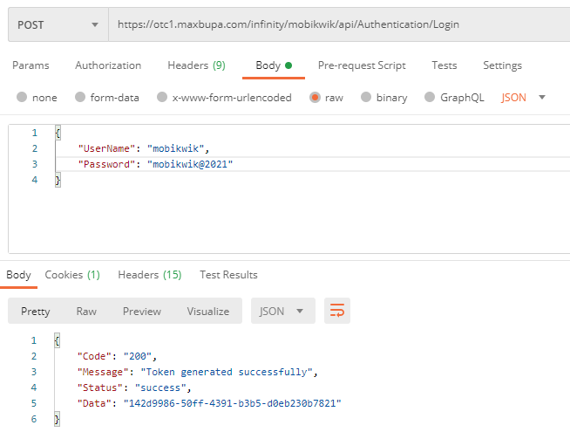

Member Push

URL https://instainfinity.nivabupa.com/mobikwik/api/integrationservices/pushmembers
Header Values
{"token":"142d9986-50ff-4391-b3b5-d0eb230b7821"}

Request Parameters

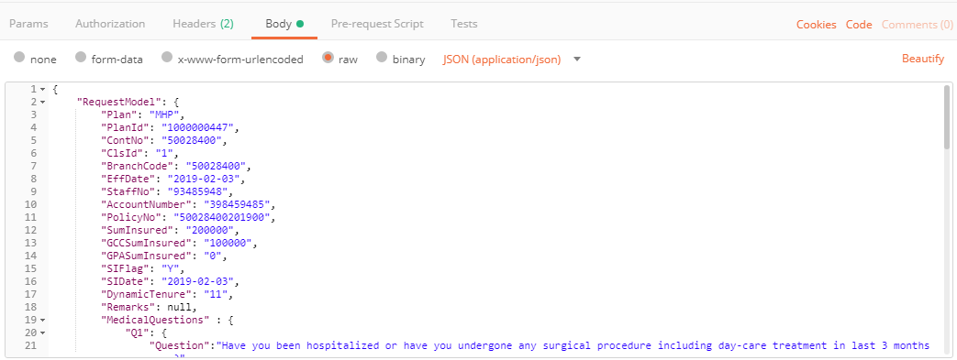

Success Response

{"Code": "200","Message": "Successfully saved.", "Status": "success", "Data": "154000300031"}

Error Response

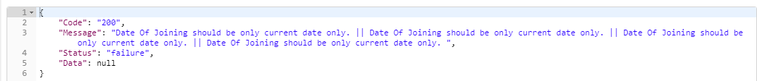

Download COI
URLhttps://instasaral.nivabupa.com/InfinityServices/COIServices/api/COIService/DownloadEncryptedCOI?coinumber=118000000241&dob=10/08/1985
Request Type “GET”
Response Result

COI Letter will download in pdf format as response.
Herewith attaching Screen for your reference with request data parameters:
